**DAILY ONLINE ACTIVITIES SUMMARY**

|  |  |  |  |  |  |  |  |  |
| --- | --- | --- | --- | --- | --- | --- | --- | --- |
| **Date:** | **28th may,2020** | | | | | **Name:** | **Prathusha K A** | |
| **Sem & Sec** | **4th sem &b section** | | | | | **USN:** | **4AL18CS061** | |
| **Online Test Summary** | | | | | | | | |
| **Subject** | | **Microcontroller and embedded systems.** | | | | | | |
| **Max. Marks** | | **20** | | **Score** | | | **16** | |
| **Certification Course Summary** | | | | | | | | |
| **Course** | **Programming for everybody (getting started with python)** | | | | | | | |
| **Certificate Provider** | | | **Coursera** | | **Duration** | | | **7 weeks** |
| **Coding Challenges** | | | | | | | | |
| **Problem Statement: In an array elements contain values from 1 to N with duplicates, the task is to find total number of sub arrays which start and end with the same element.** | | | | | | | | |
| **Status: done** | | | | | | | | |
| **Uploaded the report in Github** | | | | | **yes** | | | |
| **If yes Repository name** | | | | | **https://github.com/prathu47/lockdown-coding** | | | |
| **Uploaded the report in slack** | | | | | **yes** | | | |

Online Test Details: (Attach the snapshot and briefly write the report for the same)

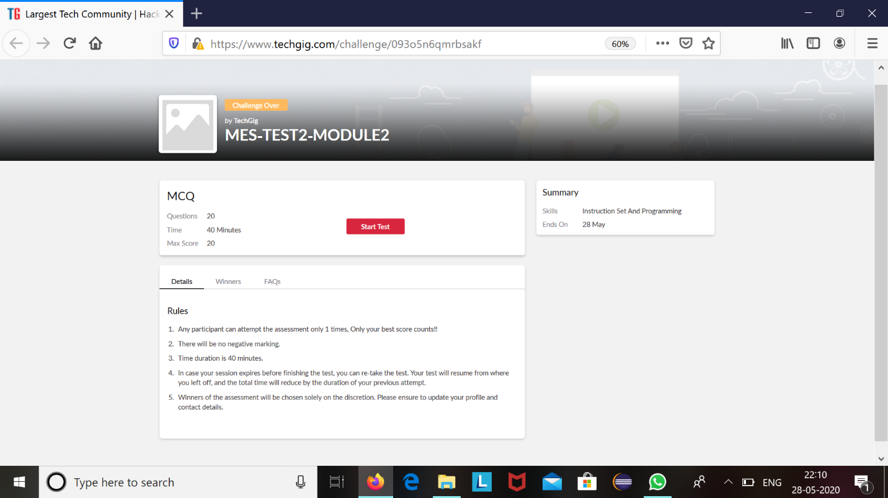

MES internals was conducted today. A total of 20 questions which is of mcq. Started at 12:00 PM and ended at 12:40 each carries one mark. Its on the topic instruction set and programming.

The above snapshot is the result sheet which was sent to us by the Techgig team.

Certification Course Details: (Attach the snapshot and briefly write the report for the same)

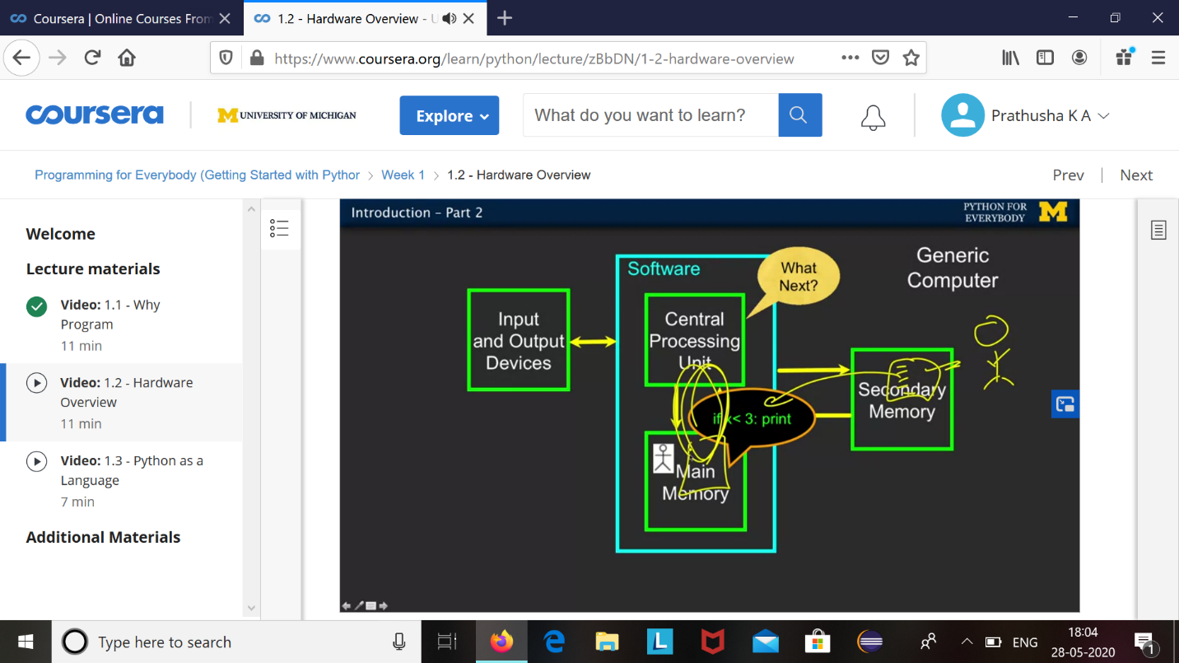

The course I have chosen during the lockdown period is programming for everybody. Since I had previously knew few topics about python iam continuing this course. Since python is gaining a lot of interest in coding platform I have preferred to choose this course.

Coding Challenges Details: (Attach the snapshot and briefly write the report for the same)

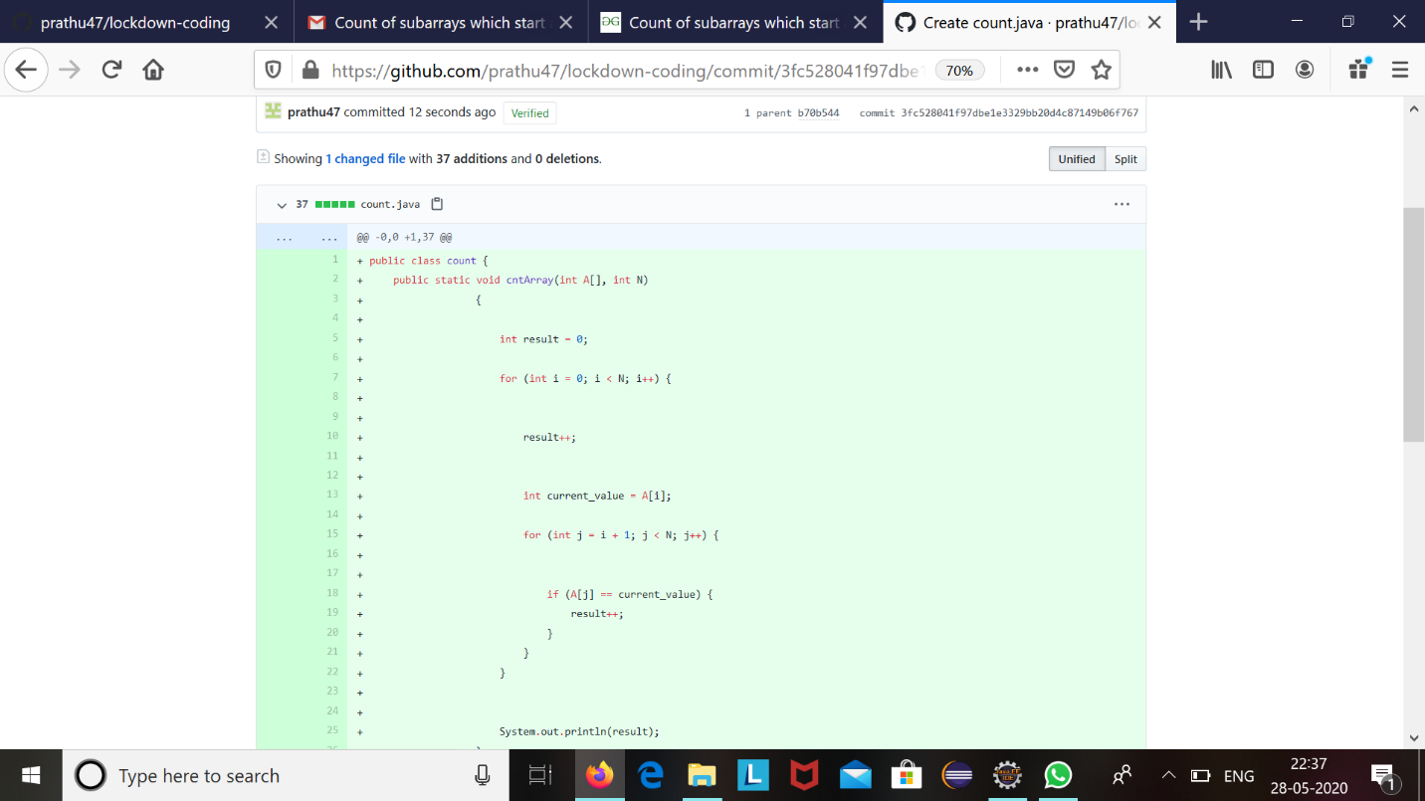

The question we had received today was :

In an array x of size N where the array elements contain values from 1 to N with duplicates,the task is to find total number of sub arrays which start and end with the same element.

Code:The above snapshot is the code which I have uploaded in my github repository.